SELF PUBLISHING? HERE ARE SOME RESOURCES TO CONSIDER
Roxanne Rustand
www.roxannerustand.com

Making the change to being an indie author was like taking myself back through grad school. There was so much to learn—and I still have so much to learn. Since everything in this world is always changing, learning can never cease, or one will soon be left in the dust.

No matter how adept you become at marketing skills, the basis of a growing indie career is writing stories that are compelling and well-edited—novels that pull the reader along and make her (or him) eager for the next book you write. Weak plotting, one-dimensional characters, and/or sloppy editing will be a death knell to your career, leading to terrible reviews that may follow your books forever. So make sure your novel is edited meticulously before you think about publishing it!

Friends and I have devoured the following books on marketing and craft, and I am always looking for new resources to study. I hope you will too—whether you are republishing old books or writing anew.

BOOKS ON PUBLISHING and MARKETING​—highly recommended

LET'S GET DIGITAL​​​ David Gaughran
AMAZON DECODED ​​David Gaughran
STRANGERS TO SUPERFANS ​ David Gaughran
BOOKBUB ADS EXPERT: MARKETING GUIDE TO AUTHOR DISCOVERY David Gaughran
​ Note: Gaughran regularly goes back into his e-books and does updates, but
beyond that, he also writes updated full revisions. Be sure you watch for the newest pub dates. For instance, Let’s Get Visible was out in 2013, and the original Let’s Get Digital first came out in 2012
AMAZON ADS FOR AUTHORS ​ Ricardo Fayet
HOW TO MARKET A BOOK ​ Ricardo Fayet
FICTION BLURBS—THE BEST PAGE FORWARD​ Bryan Cohen
ULTIMATE GUIDE TO BOOK MARKETING ​​ Nicholas Erik
SELF PUBLISHING WITH AMAZON ADS ​​ Bryan Cohen
NEWSLETTER NINJA​​​​​ Tammi LaBreque

CRAFT BOOKS: Need to spruce up your content? Here are some good ones!

EMOTIONAL BEATS​​​ Nicolas C Rossis
THE EMOTION THESAURUS​ Becca Puglisi (almost 3,400 rating on AMZ—4.8 stars)
THE EMOTIONAL WOUND THESAURUS Becca Puglisi 1,987 ratings, 4.9 stars
THE CONFLICT THESAURUS​​ Becca Puglisi 1,045 ratings, 4.8 stars
​ There are other excellent book in this series as well.

PLOT & STRUCTURE​​​ ​James Scott Bell
REVISION AND SELF-EDITING​​ James Scott Bell
WRITE YOUR NOVEL FROM THE MIDDLE ​ James Scott Bell
CONFLICT & SUSPENSE​​​​ James Scott Bell
7 FIGURE FICTION (by analyzing & studying tropes) T. Taylor
2,000 TO 10,000 WORDS Rachel Aaron
ROMANCING THE BEAT Gwen Hayes
HOW TO WRITE A MOVIE IN 21 DAYS Viki King
SCREENWRITING TRICKS FOR AUTHORS Alexandra Sokoloff
WRITE TO MARKET—DELIVER A BOOK THAT SELLS Chris Fox -- Free at his website
WIRED FOR STORY Lisa Cron

A good website article:
https://www.jessicabrody.com/2020/11/how-to-write-your-novel-using-the-save-the-cat-beat-sheet/

I’m sure you know of many other wonderful resources. I would love to hear about them!

FOR CLASSES, LONGER COURSES, AND OTHER RESOURCES

BRYAN COHEN’S FIVE-DAY AUTHOR AD CHALLENGE
​The course is offered free, four times per year. ​The next one starts July 19th, 2023
​Here is the link to sign up for the next class series, or the ones that follow: authorsadvertise.com

If you do nothing else, do this free course! Many writers take it over and over. I took it at least three times, and learned more every time.
I then joined Cohen’s Author Ad School—and it is worth its weight in gold. Lifetime access to a huge trove of courses, access (via a private FB group) to Ad School staff for feedback on your
covers, blurbs, Amazon book sales pages, ad strategies, and more. Almost every day of the week they offer Zoom forums on a variety of topics, where you can ask questions and get live feedback

ALANA TERRY -- Patreon https://successfulwriter.podia.com/​​
​ Free newsletter
Podcasts
Many courses & webinars you can take on marketing, craft, etc.
For a small monthly fee ($3, $10, or $25 per month) you can be part of Patreon.
​I’ve been a Patreon member at the $25 level for several years, which includes two
free live webinars every month plus many other benefits)
I took her course “2022 AND BEYOND AMAZON ADS CLASS” last year, and it was so
packed with information that I ended up typing up 57 pages of my notes.

NICHOLAS ERIK https://nicholaserik.com/promo-sites/
​ Definitely sign up for his free book marketing newsletter.
​ Click on the For Authors tab, to receive his free marketing guides
Next, click get his free “Mini Guide to Promo Site Strategies.” Do so!
Keep scrolling down to the bottom. Along the way, you’ll see valuable, regularly
updated lists of the best places to use for promoting your book. Hint: Bookbub and the
“Tier One” sites are the best.
The link he offers are updated regularly, and are valuable.
To do a book promotion (whether a new release or an older title) you can “stack” ads, along with Amazon ads, over a several-day period to drive sales, whether you have won a “Bookbub Featured Deal” or not.

DAVID GAUGHRAN https://davidgaughran.com/
His workshops are excellent, as are his newsletter, blog, and his books on publishing.​
Be sure to sign up for his free newsletter at
https://davidgaughran.com/following-free-newsletter/
Don’t miss reading LET’S GET DIGITAL, 2018 version (or newer, if there is one by the time you read this.)
He regularly adds updates to his books to keep the material current. (This book is a must-have.)

REEDSY
https://reedsy.com/
A wonderful resource for writing and publishing
Offers free ten-day publishing courses
Free publishing webinars
Free podcasts (many)
A blog with excellent information
Free newsletter
List of free and paid book promo sites
Tour the website—there’s more!

Ricardo Fayet is one of the founders of Reedsy.
​ He has a new book out: AMAZON ADS FOR AUTHORS I highly recommend it.
HOW TO MARKET YOUR BOOK, is also excellent, with 1,132 reviews and 4.5 stars

EXCELLENT RESOURCES FOR PUBLISHING

KINDLEPRENEUR https://kindlepreneur.com/

We Build Tools for Self-Publishers
Check out some of the resources we’ve built to help you sell more books online

MORE TOOLS
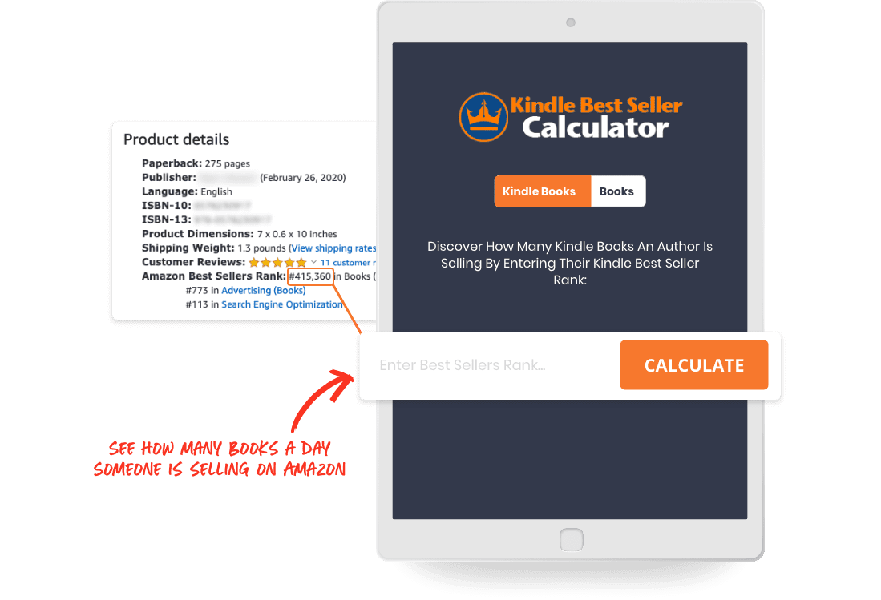

Amazon Sales Rank Calculator
This tool lets you convert Amazon’s Best Seller Rank into a rough estimate of how many Sales Per Day the book receives.
TRY OUT THIS TOOL

Book Description Generator

QR Code Generator

Free Amazon Ads Course

Free MailerLite for Authors Course

Publisher Rocket

Atticus

calibre - E-book management(
Calibre eBook
https://calibre-ebook.com

calibre: The one stop solution for all your e-book needs. Comprehensive e-book software.

I use this for converting files (example: epub → Word0

CANVA for creating memes, covers, and more ( free or paid versions)_

OTHER AUTHOR RESOURCES

FACEBOOK GROUPS
Author Support Network on FB. If you aren’t yet aware of it, join. It’s
a goldmine of valuable info via other published authors. Find this FB
page and ask to be admitted. A great place to ask questions.

Authors Optimizing Amazon and Facebook Ads—Facebook.

Plottr Writer Community on FB (this is a live link)

There are many other Facebook pages for authors of various genres. Search for those with your interests.

ORGANIZATIONS that provide valuable information
(you may know of many others)

Novelists Inc
Authors Guild
RWA
ACFW (Christian)
RWA/FHL Chapter (Christian)
Science Fiction & Fantasy Writers --website includes “Preditors & Editors” warnings
Sisters in Crime
Kiss of Death chapter of RWA
ALLI (Alliance for Independent Authors)
And there are many others…

I belonged to Author’s Guild in the early 2000’s, but left. I rejoined last year and I’m so glad I did. Besides the legal assistance they can give you with contracts, they have lengthy, excellent discussions on their email loop—a great place to ask questions on all aspects of writing and publishing.

SOME GOOD CONFERENCES TO CONSIDER

NOVELISTS INC ANNUAL CONFERENCE is one I never miss. It’s totally geared toward published authors.

20Books: https://20booksvegas.com/
Attend, or you can receive every workshop virtually for just $50
There are 190 sessions this year. See the 2023 schedule here:
https://docs.google.com/spreadsheets/d/1D6S-ZTNA4wyfvZCMmwd6FEeR5QtqLBs1mp9NeKo1rgI/edit#gid=0
ACFW (Christian)
Inkers.com ( in-person or virtual)

SOME GOOD PROMOTION SITES

Booksweeps— https://www.booksweeps.com/authors/
You can sign up for your genre-specific promotions at a low cost and receive a lot of visibility

Litring Book Promotions https://litring.com/promos
You can sign up for your genre-specific promotions at a low cost and receive a lot of visibility

Bookfunnel https://bookfunnel.com
($100 per year, but you can join as many, many group promotions as you’d like, at no cost.You can use BF for author swaps, sending ARCs, sending prizes, selling your books, and more.

Writerspace​ https://authors.writerspace.com/
A great place for increasing your visibility. It’s $150.00 per month, but they manage my newsletters, they have monthly reader contests which reach 150,000 members. (you can offer one free book, and just one winner is chosen for it, but everyone who enters is added to your personal mailing list.)

You can also blog on their website, reaching those 150,000 readers, attend their big promotion events to reach more readers, participate in their Facebook events, etc. Every year they will design a free book cover for you, but you can also use their website and bookcover design services.

Roxanne Rustand
USA Today Bestselling author
www.roxannerustand.com

